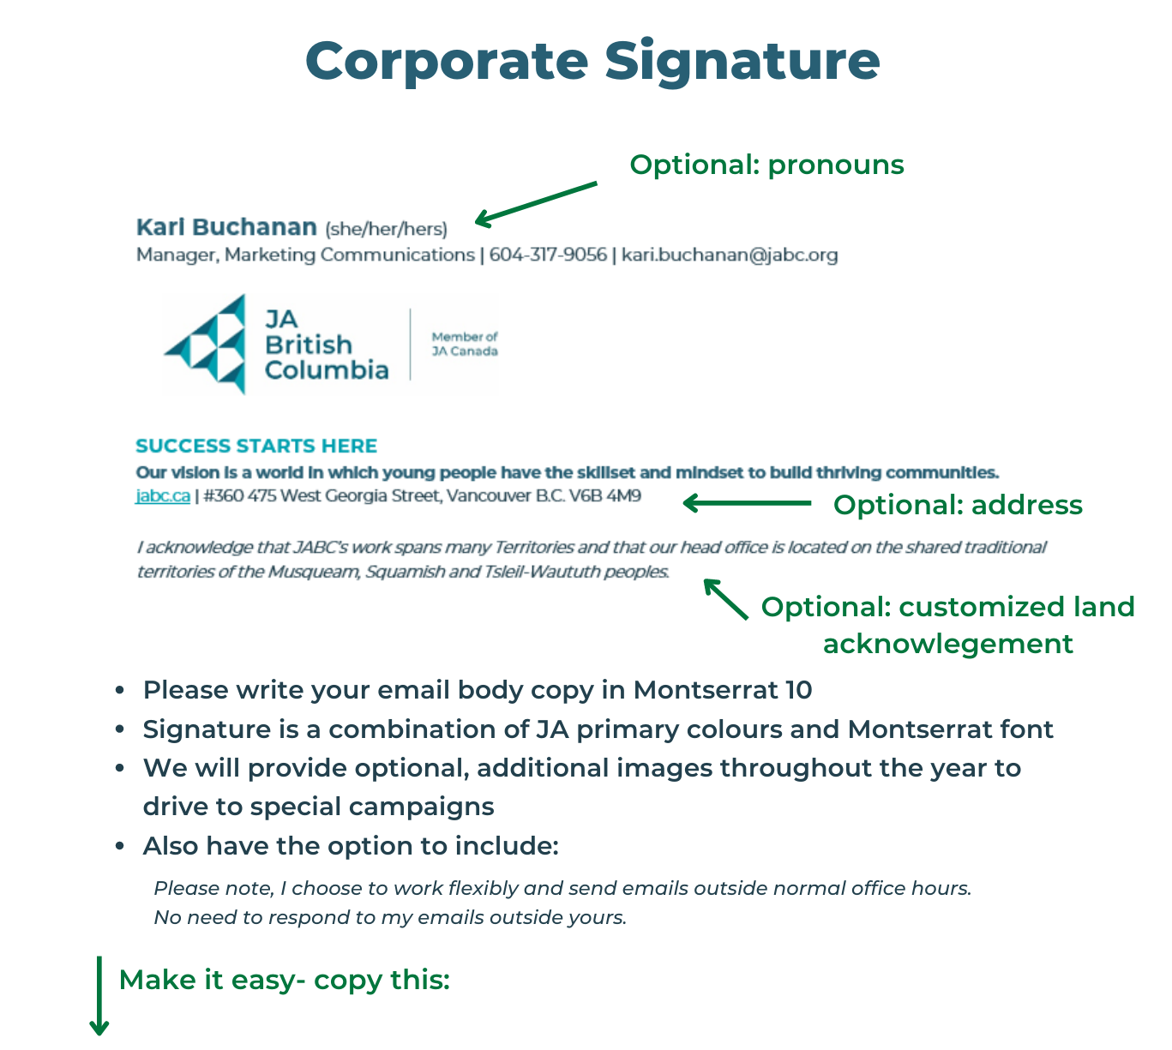
Kari Buchanan (she/her/hers)
Manager, Marketing Communications | 604-317-9056 | kari.buchanan@jabc.org

SUCCESS STARTS HERE
Our vision is a world in which young people have the skillset and mindset to build thriving communities.
jabc.ca | #360 475 West Georgia Street, Vancouver B.C. V6B 4M9

​I acknowledge that JABC’s work spans many Territories and that our head office is located on the shared traditional territories of the Musqueam, Squamish and Tsleil-Waututh peoples.

